Information and Computer Science Department
ICS 104: Introduction to Programming in Python and C
Midterm Exam, Term 212
Thursday, March 10, 2022
Duration: 120 minutes
Name: ID:
Instructor and Section: Select one
Instructor | Section
Mr. Mustafa AlTurki | [ ] 5 (UT 13 – 13:50) [ ] 6 (UT 14 – 14:50)  [ ] 7 (MW 8 – 8:50) [ ] 8 (MW 9 – 9:50)
Dr. Mohammed Amro | [ ] 1 (UT 9 – 9:50) [ ] 2 (UT 10 – 10:50)
Dr. Samer Arafat | [ ] 3 (MW 9 – 9:50) [ ] 14 (MW 10 – 10:50)
Dr. Mohamed Balah | [ ] 9 (UT 8 – 8:50) [ ] 10 (UT 9 – 9:50)  [ ] 4 (MW 10 – 10:50) [ ] 16 (MW 11 – 11:50)
Dr. Rabeah ALZaidy | [ ] F12 (UT 9 – 9:50)
Dr. Imane Boudellioua | [ ] F13 (MW 8 – 8:50) [ ] F14 (MW 9 – 9:50)

Instructions:
- Answer all questions. Make sure your answers are clear and readable.
- The exam is closed book and closed notes. No calculators or any helping aides are allowed. Make sure to turn off your mobile phone and keep it in your pocket.
3. If there is no space on the front of the page, use the back of the page. Indicate this clearly.

Question | Maximum Points | Earned Points | Remarks
Part1 | 45
Part2 | 30
Part3 | 25
Total | 100

11111111111111111111111111111111111111111111111111111111111111111111
Part 1 : MCQ questions [ 30 x 1.5 = 45 points ]: (Make sure to bubble the correct answer in the green sheet)
1) What will be the output of the following code fragment?

week = week – 1
sent = "hello week" + str(week)
print(sent)

  - hello week
  - hello week1
  - hello week week - 1
  - The code will result in an error.
2) What will be the value of the variable myValue after executing this statement?

myValue = (543 // 10) % 10

  - 4
  - 0
  - 543
  - 5
3) Which one of the following is a valid variable name in Python?
  - for
  - !grade
  - _a2
  - 4_rent
4) For the following mathematical formula, which expression is equivalent in Python?
$$S= 5x+ \frac{xy^{2}+|r|}{x-4}$$
  - S = (5 * x) + (x * y ** 2 + abs(r))/(x - 4)
  - S = 5 * x + x * y ** 2 + abs(r) / x - 4
  - S = (5 * x + x * y ** 2 + abs(r)) / (x – 4)
  - S = (5 * x + x * y ** 2 + abs(r)) / x - 4
5) What will be the value of the variable total after executing the following statement?
total = 2 ** 3 ** 2 + 5

  - 2¹⁴
  - 5 + 2⁹
  - 8⁷
  - 5 + 8²

6) What will be the output of the following code fragment?
check = False
total = 4
while not check:
while total >= 0:
if total % 2 == 0:
print("q", end="")
check = True
total = total - 1

  - q
  - qq
  - qqq
  - qqqq
7) What will be the output of the following code fragment?
x = 1
for i in range(3, 7, 2):
x = x + 1
for j in range(1, 3):
x = x - 1
print(x, end="")
  - 1100
  - 0-10-1
  - 0220
  - 100-1

8) What will be the output of the following code fragment?
a = "August"
b = "July"
c = "January"
if a < b:
print("b1", end="")
if b < c:
print("b2", end="")
elif a < c:
print("b3", end="")
else:
print("b4", end="")
  - b1
  - b1b2b3b4
  - b1b3
  - b1b2b3

9) What will be the output of the following code fragment?
name = "i34pa5d2"
for i in range(len(name)):
if name[i].isalpha():
print(i, end="")
  - 0346
  - ipad
  - 1457
  - 3452

10) What will be the output of the following python code when the input is 5 ?

num = int(input("Please a number: "))
if num != 0:
if num >= 5.0:
print("first block is executed")
elif num == 5:
print("third block is executed")
else:
print("second block is executed ")
else:
print("No output")

  - Program will print "third block is executed".
  - Program will print "first block is executed".
  - Program will print "No output".
  - Program will print "second block is executed".
11) What will be the output if you try to run the following python code?
n = 2
m = 5
if m + n > 0 or m/(n-2) > 0:
print("m + n = %d"%(m + n))
else:
print("m - n = %d"%(m - n))

  - m + n = 7
  - Syntax error message
  - Division by zero error message
  - m - n = 3

12) What will be the output of the following code fragment?
i = 6
if i > 0:
for j in range(2, 4):
print(i*j, end="")
i = i - 3
  - 12
  - 129
  - 1290
  - 121869

13) What will be the output of the following code fragment?
courseName = "COE" + "24" + "1"
courseName = courseName + "Data and Computer"
print(courseName)

  - COE241Data and Computer
  - COE25Data and Computer
  - Data and Computer
  - The code will result in an error.

14) What will be the output of the following code fragment?
s = "123"
for i in range(2):
s = s[i] * 3
print(s)

  - 111
  - 111333
  - 222
  - 123

15) Which of the following is the correct way to check that the substring "ICS" does not exist in courseName string variable?

courseName = "ICS104"

- courseName is not "ICS"
- "ICS" not in courseName
- "ICS".find(courseName)
- "ICS".count(courseName)

16) Assume the variable CourseName is a string, which of the following is the correct way to check if the string CourseName consists of only letters or digits and it contains at least one character?
A. if isalnum(CourseName)== True:
B. if CourseName.isalpha():
C. if isalpha(CourseName) == True:
D. if CourseName.isalnum():

17) Consider the following Python code
name = "CHEM 101"
id = 202012134
Choose the correct answer

  - print(name.isspace()) will display True
  - print(name.isalnum()) will display True
  - print(name.isupper()) will display True
  - print(id.isdigit()) will display True

18) What will be the output of the following print statement?
print('name%3sAge%-3d'%('Ali',37))
  - Ali37
  - nameAliAge37
  - name Ali Age 37
  - name%sAliAge%-3d37

19) A string is stored in a variable called empRecord.
The string ends with a number that is always 2 digits that represent employee age.
For example:
empRecord = "Ali's age is 37"
Which of the following is the right way to extract the number and convert it into an integer value?
  - age = empRecord[len(empRecord) - 3 : len(empRecord)]
  - age = empRecord[len(empRecord) - 2 : len(empRecord)]
  - age = int(empRecord[len(empRecord) – 2 : len(empRecord) – 1])
  - age = int(empRecord[len(empRecord) – 2 : ])

20) Select the correct option based on the below python code.
richter = 0
if richter >= 8:
print("Most structures fail")
if richter >= 5:
print("Many buildings destroyed")
else:
if richter == 0.0:
print("No destruction of buildings")

  - No output is generated.
  - Program will give syntax error.
  - Program will print "Most structures fail ".
  - Program will print "No destruction of buildings ".

21) The CPU includes which of the following parts:
- Hard disk
- RAM
- Arithmetic logic unit
- ROM
22) Which of the following Python expressions gives the same result as:
"T" > "C"
- "T" - "C" > 0
- "C"+"T" > "C"*2
- "T" + 1 > "C" + 1
- "A" > "C"
23) Given this line of code, what is the expected result:
print(5 * 2 ** 3 // 2)

Which of the following is the correct output of the line of code, above:
- 10
- 500
- 20
- 15

24) Given this line of code, what is the expected result:

print((1 + 2) * 2 ** 3 % 2)

Which of the following is the correct output of the line of code, above:
- 0
- 1
- 5
- 9

25) Given this line of code, what is the expected result:

print((0 or 2) and (not False or False))

Which of the following is the correct output of the line of code, above:
- 2
- True
- False
- An error message will be printed

26) Given this line of code, what is the expected result:

print("" or (4 < 4))

Which of the following is the correct output of the line of code, above:
- 4
- True
- False
- An error message will be printed

27) Given this code fragment, what is the expected result when the user enters 5.9 as input?:
value = float(input("Enter a value:"))
value = int(value)
print(value)

Which of the following is the correct output of the line of code, above:
- 5.0
- 6
- 5.9
- 5

28) Given this code fragment, what is the expected result when the user enters 3.2 as input?

value = float(input("Enter a value:"))
value = str(value)
value = value + " kilos"
print(value)

Which of the following is the correct output of the line of code, above:
- kilos
- 3.2
- 3.2 kilos
- An error message will be displayed

29) Given the following code segment:

n = 10
while n < 90:
n = 2 * n
print(n)

what is the LAST VALUE that will be printed, just before the loop is terminated:
- 160
- 120
- 90
- 80

30) Given the following code segment:

string = "20Boxes6-packs"
i = len(string) - 1
done = False
while i >= 0 and not done :
if string[i].isdigit():
done = True
else :
i = i - 1
print(i)

What is the value that will be printed when this code finishes execution:
- 1
- 6
- 0
- 7

Version 1
Part 2. [ 30 Points] Show output
1) What will be the value for each of the following python expressions? (pay attention to the data type).

10 points points (1 point for each value)
( If value correct but type is wrong ½ point like 3 instead of 3.0)

Expression | Value
round(21.517,2) | 21.52
18 // 4 + 10 % 2 | 4
float("1.72"+"5")+5.0 | 6.725
"ABC" < "D" | True
5 and not "" | True
5 / 2 * 2 - sqrt(16) | 1.0
8657 // 100 % 10 | 6
6 + 3 < 4 < 10 | False
5 > 3 % 4 + 3 | False
2 – 3 * 4 / 2 + 2 * 2 / (6-4) | -2.0

2) What will be the output of the following python code fragments?
Output Box
# 4 pts  for i in range(4,0,-2):  count=i  while count >= 0:  print(count,end="")  count=count-1  if count == 1:  print() | 432  102  10  1 pt for each line  1 pt correct format i.e.  Printing in 3 lines
val = 10 # 2 pts  num = 2  if num > 1 or val != 10:  if num < 4:  num = val ** num  elif num == 2:  num = 0  val = val/2  else:  val = num  num = num + 1  print(num)  print(val) | 100  10  1 pt for each value
Version 1 # 2 pts  num = int(input("Enter a number: "))  if num > 0:  print("A")  if num == 4:  print("B")  else:  print("C") | User input is: 4  A  B  (1 pt for each letter)
# 2 pts  st1='KFUPM'  st2=""  for i in range(len(st1)):  if i%2 == 0:  st2 = st2 + st1[i].lower()  print(st2) |  | kum  (lower case 1 pt)  (same letters 1 pt)
# 2 pts  for x in range(2):  print(x)  if not x:  print(x+1)  else:  print(x-1) |  | 0  1  1  0  (0.5 pt for each value)
# 2 pts  sub="ABCDE"  i=1  j=5  while i<j:  print(sub[i:j])  i=i+1  j=j-1 |  | BCDE  CD  1 pt for BCDE  1 pt for CD
x = 2 # 2 pts  y = 3  z = 6  if z >= x or x > y:  print("first")  if z:  print("second")  if not x == 2:  print("third") |  | first  second  ( 1 point each)  Extra output -1 )
phrase = "212-ICS-Midterm" # 4 pts  d= len(phrase)  a = int(phrase[2]) -1  b = phrase.find('-')  c = phrase[8:]  print(d,a,b,c) |  | 15 1 3 Midterm  1 point for exact match of each value, 0 otherwise

Part 3. [ 25 Points] Code writing
1) 10 points
Convert the following flowchart into its equivalent python code.
Note: Simple if’s are not allowed. You have to use nested if-else and/or multiway if statements.
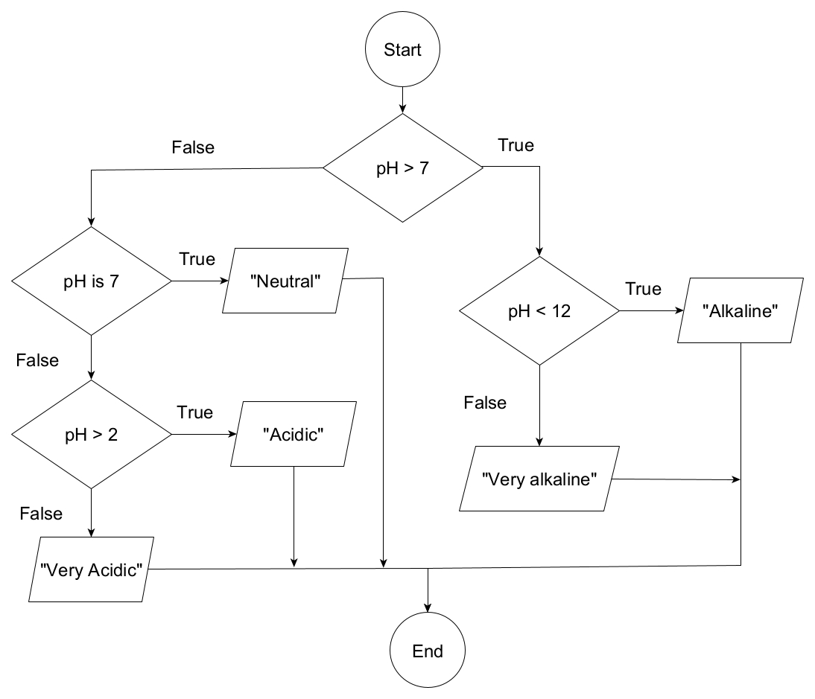

Solution 1
if pH > 7: ------------------ 1 pt
if pH < 12: --------------- 1.5 pts
print("Alkaline") --------------------- 0.5 pt
else: ---------------------- 1 pt
print("very alkaline") --------------- 0.5 pt print
elif pH == 7: ----------------- 1.5 pts
print("Neutral") -------------------------- 0.5 pt
elif pH > 2: -------------------- 1.5 pts
print("Acidic") ---------------------------- 0.5 pt
else: ------------------------------ 1 pt
print ("Very Acidic") ------------------------ 0.5 print

Solution 2
if pH > 7: ------------------ 1 pt
if pH < 12: --------------- 1.5 pts
print("Alkaline") --------------------- 0.5 pt
else: ------------------------- 1 pt
print("very alkaline") --------------- 0.5 pt
else: ------------------------------ 0.5 pt
if pH == 7: --------------------- 1 pt
print("Neutral") -------------------------- 0.5 pt
else: --------------------------- 0.5 pt
if pH > 2: --------------------- 1 pt
print("Acidic") ------------------ 0.5 pt
else: --------------------------- 1 pt
print ("Very Acidic") ------------------------ 0.5 else and print

2) 15 points
Write a complete Python program that models a guess-number game. The program generates a random number in the range from 0 to 20 (inclusive) and the user (player) tries to guess this number. The program will guide the user throughout the game, such that, when the user enters a wrong number, the program will display either “Your guess is bigger” or “your guess is smaller” until the user finds the correct answer. Then, it will display the number of trials to get the correct answer as shown in the sample run.
Sample Run:
Enter your guess 0 to 20: 10
Your guess is bigger
Enter your guess 0 to 20: 5
Your guess is bigger
Enter your guess 0 to 20: 2
Your guess is smaller
Enter your guess 0 to 20: 3
Correct: It took you 4 trials

Solution1
from random import randint ---------------------------------- 1 pt
numToGuess=randint(0,20) ------------------------------------- 1 pt
trials=0 ----------------------------------------------------- 1 pt
userGuess=-1 # an value not in [0,20] ------------------------ 1 pt
while userGuess != numToGuess: -----------------4 pts (2 for loop, 2 for cond)
trials=trials+1 ------------------------------------------- 1 pt
userGuess=int(input("Enter your guess 0 to 20: ")) --------- 1 pt
if userGuess == numToGuess: ----------------------------- 1 pt
print("Correct: It took you",trials,'trials') --------- 1 pt
elif userGuess > numToGuess: ---------------------------- 1 pt
print("Your guess is bigger") ----------------------- 0.5 pt
else: ------------------------------------------------ 1 pt
print("Your guess is smaller") ------------------- 0.5 pt
===============================================================================

solution 2
from random import randint ----------------------- 1 pt
numToGuess=randint(0,20) ------------------------- 1 pt
trials=1 ------------------------------------------ 1 pt
userGuess=int(input("Enter your guess 0 to 20: "))----- 1 pt
while userGuess != numToGuess: --------------- 4 pts (2 for loop, 2 for cond)
if userGuess > numToGuess: ------------------------ 1 pt
print("Your guess is bigger") -------------- 0.5 pt
else: (or elif userGuess > numToGuess) -------------------- 1 pt
print("Your guess is smaller") ------------- 0.5 pt
userGuess=int(input("Enter your guess 0 to 20: ")) ----- 1 pt
trials=trials+1 -------------------------------------- 1 pt
print("Correct: It took you ",trials,'trials') -------------- 2 pts
Remark: for the above solution, there is no if userGuess == numToGuess inside the loop. If the 2 values are equal, the execution does not enter the loop. So no point to be given for this if condition in the loop. The last print does not need if.

Solution 3: Many students may use the break statement

from random import randint #----------------------- 1 pt
numToGuess=randint(0,20) #------------------------- 1 pt
trials=0 #------------------------------------------ 1 pt
while True: #--------------- 3 pts (2 for loop, 1 for cond)
userGuess=int(input("Enter your guess 0 to 20: ")) ----- 1 pt
trials=trials+1 ------------------------------------- 1 pt
if userGuess == numToGuess: ------------------------ 1 pt
print("Correct: It took you ",trials,'trials') ------- 1 pt
break; ---------------------------------------- 2 pts
elif userGuess > numToGuess: #------------------------ 1 pt
print("Your guess is bigger") #-------------- 0.5 pt
else: ------------------------------------------ 1 pt
print("Your guess is smaller") --------------- 0.5 pt

